**68. Spring REST - CRUD Database Project - Delete Customer**

**Delete Customer**:

Here we will delete a customer from the database. We will send over a DELEETE request "/api/customer/{customerId}". In the background our application does the apocopate work, delete the customer and send back a response saying "Delete customer id: {customerId}".

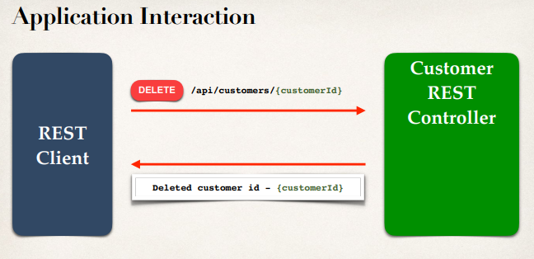

**Delete customer**:

@RestController

@RequestMapping("/api")

**public** **class** CustomerRestController {

...

// add mapping for DELETE /customers/{customerId} - delete an existing

customer

@DeleteMapping("/customers/{customerId}")

**public** String deleteCustomer(@PathVariable **int** customerId) {

Customer tempCustomer = customerService.getCustomer(customerId);

// throw exception if null

**if** (tempCustomer == **null**) {

**throw** **new** CustomerNotFoundException("Customer id not found: " +

customerId);

}

customerService.deleteCustomer(customerId);

**return** "Deleted customer id: " + customerId;

}

}

68. Spring REST - CRUD Database Project - Delete Customer